**Task 01**

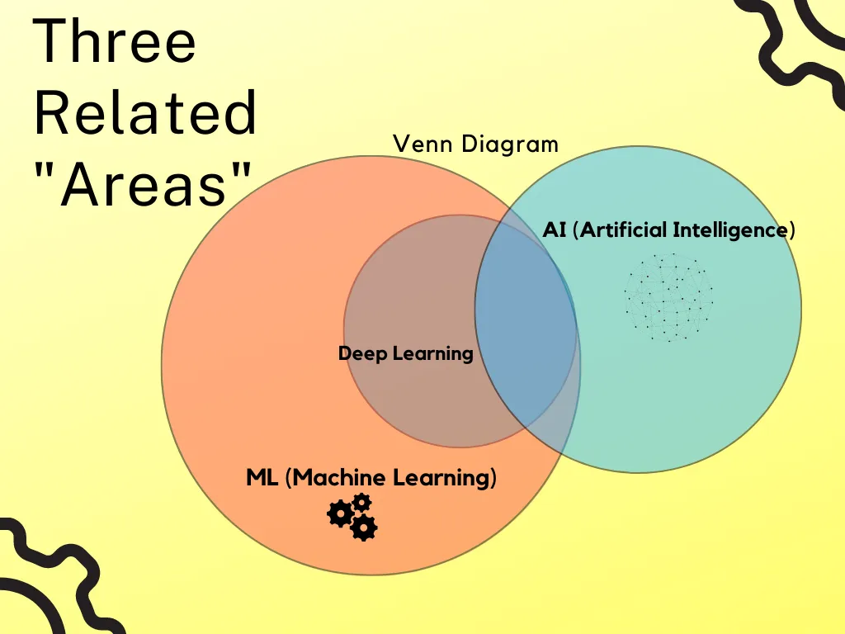

**1. Artificial Intelligence (AI)**

Think of **AI** as the **big umbrella**.  
It’s all about making machines smart so they can do tasks that normally need human intelligence.

* **Example:** When Siri or Google Assistant answers your question, that’s AI.
* It’s not perfect, but it tries to “think” like a human.

**2. Machine Learning (ML)**

**ML is a way of achieving AI.**  
Instead of teaching a machine every single rule, we give it data and let it learn patterns.

* **Example:** A spam filter in Gmail.
  + We don’t write “if this word appears, then it’s spam.”
  + Instead, we feed the machine lots of examples of spam and non-spam emails, and it **learns** the difference.

**3. Deep Learning (DL)**

**DL is a more advanced type of ML** that works kind of like how our brain’s neurons connect.  
It uses **neural networks with many layers**—that’s why it’s called “deep.”

* **Example:** Facebook tagging your face in photos.
  + The system doesn’t just see pixels.
  + It automatically learns features like eyes, nose, smile, and then recognizes you.

Deep Learning shines when we have **huge amounts of data** (like millions of photos or hours of audio).

**4. Generative AI (GenAI)**

This is the **new kid on the block**.  
While traditional AI mostly predicts or classifies things, **Generative AI actually creates new content.**

* **Example:**
  + **ChatGPT** can write essays or code.
  + **DALL·E or MidJourney** can create original images from text prompts.
  + **Music AI** can compose new songs.